Workplace Travel Plan Template

Leigh Leisure Centre
Leigh Leisure Centre, Sale Way, WN7 4JY
27 March 2011
Contents Page

Executive Summary 1
1. Introduction 3
1.1 Introduction 3
1.2 This travel plan 3
1.3 Policy 4
2. Existing travel situation 6
2.1 Introduction 6
2.2 Our organisation and activities at this site 6
2.3 Site location 7
2.4 Site assessment 7
2.5 Staff travel surveys 21
2.6 Visitor/patient/student/customer travel surveys 41
3. Objectives, Targets and Indicators 43
3.1 Introduction 43
3.2 Objectives 43
3.3 Targets and indicators 44
4. Travel Plan Strategy 46
4.1 Introduction 46
4.2 Managing the plan: roles and responsibilities 46
4.3 Marketing 48
5. Package of Measures for Employees 50
5.2 Introduction 50
5.3 Walking 50
5.4 Cycling 51
5.5 Public transport access 52
5.6 Managing car use 54
5.7 Powered two wheelers 55
5.8 Reducing the need to travel 56
5.9 Business travel 57
5.10 Deliveries and servicing 59
5.11 Travel information and planning 59
6. Measures for 61
6.2 Introduction 61
7. Monitoring and Review 62
7.1 Introduction 62
7.2 Monitoring plan 62
7.3 Reporting 63
8. Action Plan 64
8.1 Introduction 64
8.2 Action Plan 64
Appendix 1 - Policy context 65
National Policy 66
Regional Policy 66
Local Policy 66
Appendix 2 - Staff survey questionnaire 67
Appendix 3 – Results of staff survey 68

Executive Summary
This document looks at the current modes of travel to and from the centre and how this can be improved to help reduce the carbon footprint of everyone using the centre. It takes into cosidreration the facilities that are available on site for commuters and the transport links to the site. It also identifies areas that we can try to improve on to increace commuters to access the centre without the use of a motorised vehicle.
Introduction
This travel plan is for Leigh Indoor Sports Center, on the sports village. The travel plan is aimed at reducing the impact of travel to and from Leigh Indoor Sports Centre. This will demonstrate our commitment to our employees and site users by Improved business efficiency and equality within the travel plan.
This document is not builds upon or replaces an existing TP document.
Our main types of users are staff, visitor, students, customers for this site that are covered by this TP. Contractor may be unawear that there is a travel plan on site and therefore not covered.
The timescale for the travel plan is 5 years. Over the period inwhich we measure, implemented and progress towards targets monitored – this wil be 5 years. For development related travel plans (e.g. the planning process), the commitment required by the Authority can be longer than 5 years and they sometimes require a revised document to be submitted after 5 years. At leigh indoor sport cemter:
2011- template with site audits and staff surveys
2012- completed staff surveys to page 70 appendix number 2
2013- not listed
2014- completed staff surveys to page 70 appendix number 2+3
2015-
2016-
2017-

Existing travel situation
Leigh Indoor Sports Centre is located on the Leigh sports Village. It is a re-developed retail and recreational area with direct access from a major road (A579). The site has ample parking and is also has a bus route (the 579) from Leigh bus station. There are also many footpaths that lead to the area.
Staff at the site work on a shift basis, traveling to and from site from between 0700 and 2300

Objectives and targets
Low cost, no cost measures- encourage customer to use public transport by listing bus routes, nearest rail stations ect next time leaflets are reprinted. When travelling by car, plan your route to reduce mileage and avoid rush hour periods. Check vehicle tyre pressure regularly. Use air conditioning in the car only when really necessary.
Medium, to long term measures- provide a secure cycle parking area. Cycle park must be well lit. is it covered by CCTV or overlooked by staff? Consider he use of telephone conference calling or video conferencing to avoid travelling to meetings.
Travel plan strategy
Rebecca Whittle is travel plan co-ordinator, with time to undertake this role within duty supervisor role at Leigh Indoor Sport Centre. Also steering group with Wigan Council have regular meetings. The plan will be managed by following the the action plan which lie within our environmental policy in the transport session EMS2.13
Key measures for employees
- Walk, or cycle to work if you live in close proximity and if safe to do so.
- Utilise public transport where possible.
- Car share if working same or similar shifts.
Key measures for other users
Public
- Walk or cycle to the centre
- Use the dedicated public transport
- Car share were possible
Schools
- Use private hire bus or coach
Monitoring and review
This travel plan includes a monitoring and review strategy, recognising that implementation and continuation of this travel plan is an ongoing process. The plan will be monitored in accordance with the requirements of Wigan Council.
Action Plan
Our travel plan is guided by our action plan (below). This summarises the key travel plan development and implementation tasks that we intend to take. It also highlights key project milestones.
When | Activity | By whom
 | Car share to meetings when appropriate | All
 | Walk and cycle to work if possible | All
 | Help to buy a bike Scheme with the local council. | Council
 | Ride Safety Lessons. | Council
 | New bicycle shelters | Facilities Team

Introduction

Introduction

A travel plan is a long term management strategy for an organisation or site that seeks to deliver sustainable transport objectives through action and is articulated in a document that is regularly reviewed. A travel plan involves identifying an appropriate package of measures aimed at promoting sustainable travel, with an emphasis on reducing reliance on single occupancy car journeys. It can also assist in meeting a range of other objectives, as discussed elsewhere in this document.

Travel plans can assist in increasing accessibility whilst reducing congestion, local air pollution, greenhouse gases and noise. Importantly, a travel plan can increase business efficiency and equality, which is why an increasing number of organisations are deciding to produce voluntary travel plans.

A well developed travel plan can mitigate adverse traffic impacts of a development and the Government recognises their importance in achieving improvements in transport conditions at the local level. Further evidence suggests that people who are physically active in their daily lives are more productive and have good attendance records. The Department for Health publication Choosing Health: Making healthy choices easier (2004) recognised the health benefits of walking or cycling. Active travel as part of a travel plan enables people to enjoy these health benefits as part of their daily routine.

This travel plan

This travel plan has been produced for Leigh Sports Centre which is located in Wigan. The travel plan is aimed at reducing the impact of travel to and from our site at:

Leigh Sports Centre, Sale Way, WN7 4JY

Our main reasons for implementing a travel plan are…
        - Improved business efficiency and equality;
        - Enhanced recruitment and retention of staff;
        - Local or onsite congestion or parking pressures;
        - Corporate social responsibility;
        - Wishing to be a ‘good neighbour’;
        - Working towards accreditation for an Environmental Management System (e.g. ISO 14001);
        - Submission of or conditions attached to a planning application for your site; and so forth.

The travel plan will cover:
                - Commuting to/from our site;
                - Travel during the course of our business;
                - Travel to our site by visitors;
                - Travel to our site by suppliers.

This document provides an overview of the current situation and transport arrangements at our site. It also sets out measures which we will be introducing in order to meet our travel plan objectives.

This document will be regularly reviewed, reflecting that a travel plan is a continuous process for improvement, requiring monitoring and revision to ensure it remains relevant to our organisation and those using the site. The document will next be revised September 2020.

Policy

Travel plans have become an important tool for the delivery of national, regional and local transport policy and commonly play an integral aspect within the planning process, fulfilling a role in encouraging more sustainable development. As a result, travel plans are required in association with all significant planning applications and information on the planning policy context is given in Appendix 1. Nevertheless, a new development and the transport obligations which are associated with it (to make it acceptable) are not the only motivation for introducing a travel plan.

Enter here any further policy statements that may be relevant.

Existing travel situation

Introduction

This chapter provides an overview of our organisation and the current travel and transport situation at our site. It is based upon the findings of a thorough site assessment and baseline travel surveys.

Our organisation and activities at this site

The business is within leisure industry, and some of the activities that take place at Leigh Indoor Sports Centre are: Gym, Swimming, Fitness Classes, Football, Badminton
        - 31 staff employed on this site.
        - Monday- Friday 7am- 11.00pm Saturday- Sunday 7am- 5.30pm
WLCT leisure centres, which includes Leigh Indoor Sports Centre has a large number (20,000 per month) of pupils/visitors/customers per annum.
Across the borough WLCT has 6 Gyms and 4 Pools. At Leigh Indoor Sports Centre we have Duty Managers, Duty Superviors, Recreation Assistants , Swimming Instructors, Fitness Insturctors and Reception staff opprate within the building opening times which are 7am- 11.00pm Monday- Friday and 7am-5.30pm Saturday- Sunday.

Site location
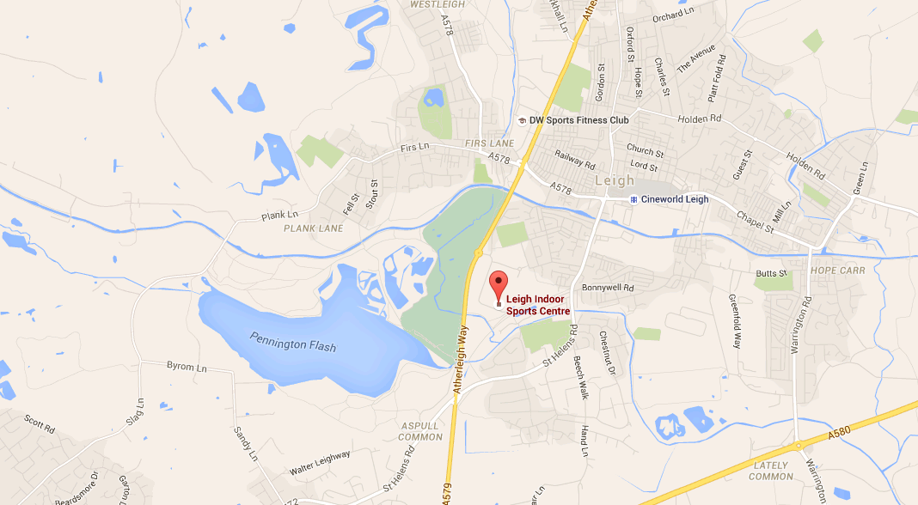
The centre is located outside of the town centre on a sports complex with stadium, athletics track, additional 3G pitches, hotel, sixth form college and a supermarket. Nearest bus stop is across the road from the centres main entrance.

Site assessment
The site has several shared car parks which are currently used as the majority of staff travel in via car.
There is a shower in the staff room area for employees who cycle or walk to work and wish to shower before commencing their shift.
Look at the possibility of creating more cycle storage to encourage cycling to the site.

Site Access

Our site can be accessed from Sale Way off the Atherleigh Way (A579).
This is the only entrances via vehicle. However public transport (bus) can access via Marshal Street. Both can routes can be accesses by cycling and pedestrians.

Car use

Car Parking

We do have parking on site, this is for the use of our employees and shared with the public and other organisations in the area. We do not have our own private car park. The parking managed by the stadium organisation

There are 0 spaced designated to the Sports Centre alone.

Table 2.1 shows the current availability of parking spaces at our site for different categories of user.

Leigh Indoor Sports Centre share parking with the sports village and the stadium has provide car parking stewards. To help with the events and access of the barriers on the car parks.
Table 2.1: Current availability of parking for our site
Spaces for | Number of spaces | Charges | Comments
Employees | 0 | N/A | N/A
Senior Staff | 0 | N/A | N/A
Disabled | 12 | No charges | These are located close to entrances. Badge must be shown.
Visitors | 500 | No charges | No restrictions on the use.
Car sharers | 0 | No charges | N/A
Fleet cars | 0 | No charges | Where are these located? E.g. close to entrances, under cover.
HGV’s | 0 | No charges | Barries on all car parks they can be accessed from holiday inn hotel where the car parking stewards.
Total: | 0 | N/a | N/a
Additional drop off/ pick up spaces | 1 | Free to use | No restrictions
No restrictions on cars however all car parks on the sports village have barriers and will need opening if a vehicle is over the height of 2.1 metres. By the stadium car parking stewards.

Spaces are managed by the stadium car parking stewards. During events such as match days they may designate specific car parks for specific uses i.e. T.V broadcasting vans, team and supporter coaches, dignitaries etc. otherwise there are no restrictions.

There is no charge for car parking.

Enforcement is on site and will monitor people parking in disabled bays without a badge, parking in loading bays and bus stops. There is a barrier system installed to restrict vehicles over 2.1m from entering however these bariers can be unlocked by stewards as and when required.

Our car parking areas are well signed, maintained, marked, well lit and some are monitored by CCTV or a Hawk Eye mobile surveillance van.

There are no other issues.

Car Sharing

‘Car Sharing’ refers to a situation where two or more people travel by car together, for all or part of the car trip.

As shown in Table 2.1 there are 0 spaces are designated for the use of car sharers.

At present there are no staff who car share

Car Club

We do not have a car club

Fleet vehicles

We currently have 1 box van which is shared between multiple sites. This van is only driven by specific insured drivers. On average it travels around 8000 miles a year.

Issues

We can experience a heavy flow of traffic and limited car parking spaces during match days at the stadium. There is also an increase in pedestrian activity during this period.

Cycling

There are no dedicated cycle routs to the centre however there is access from several major roads and cycle friendly pathways.
There is space for cycle parking; we currently have 18 spaces located at the side of the sports hall, just around the corner from the main entrance. These spaces are not sheltered any you need to provide your own lock. This area is well lit and covered by CCTV.

Motorcycling

We have 18 motorcycle spaces available at the side of the sports hall (shared with bicycles). They are uncovered and require locks provided by the individual. This area is well lit and covered by CCTV.

Pedestrian access

The centre can be accessed via various pedestrian routes. The routes in the immediate vicinity to the centre are well lit and the majority are covered by CCTV. They offer easy accessible routes for disabled customers who may require assistance. Routes further afield are not covered by CCTV and some may not be stone footpaths that are not lit and lined with large trees and vegetation.

Supporting facilities

Facilities are available for all staff who walk or cycle to work. These include a
single unisex shower and changing area, lockers that are larde enough to store clothing, helmets can be stored in a staff room.

Public transport access

The centre can be reached on the 597 service from Leigh bus station. This is a circular route from the bus station to the centre and back. The journey from the bust station to the centre can take around 5 -10 minutes depending on the time of day and associated traffic. The bus stop is across the road from the centres main entrance.

Bus

Table 2.2 summarises the availability of bus services within 400m of our site. The time table for this service is located within the centre, the stops are not sheltered and there is no seating. The stops are well lit and the buses are clean.
Table 2.2: Bus stops within 400m
Location | Number of stops | Services which call here | Description of stop | Key destinations
Main Entrance | 1 | 579 | Lay-by across the road | Leigh Bus Station

Surface Rail

There are no rail stations within 1km on the centre.

Park and Ride

There is no park and ride facility to the centre.

Private bus/minibus

Local companys include:

JR’s / Avacab Taxi – 01942 681168

Zcarz – 01942 677107

Arrangements for business travel

By Car

Only certain employees claim for business travel, this is usually when traveling

to meetings in other geographical areas. They will use their own vehicle, no company cars are provided.

By Cycle

Cycling is cheap, offers reliable journey times and is environmentally friendly.
Within the workplace, encouragement of cycling can lead to a healthier, more productive work force.
There are no provisions for cycling business travel

By motorcycle

There are no provisions for motorcycle business travel.

Reducing the need to travel during the course of business

The centre has computer teminals that allow ‘Hot Desking’ meaning staff from
other sites can use the terminals on site to access their work, reducing the need to travel to a additional sites to retrieve their information.

Deliveries

Deliverys generaly take place at the front of the building in the designated
loading area. They arrive during operational hours were staff will be able to assist with the delivery. On average ther are around 10 deliverys a week.

Reducing the need to travel to work

There is no policy to recruit localy or to supliment relocation costs. Flexitime is
also unavailable along with compressed working weeks.

Travel during the day

There is not a great need to travel during working hours, exceptions to this are if
there is a need to travel to another site to pick up equipment or materials. Also if a member of staff is required to cover at another site at short notice.

Travel information/ planning

For employees

Appropriate travel information is available for all staff, this is diaplayed and staff
are fully aware of the modes of transport that are available for the centre.

For new recruits

All new employes are given information on how to travel to the centre for an
interview (if the interview is to be held at this site). Recruits who have not been interviewed by the site will be given the appropriate travel information before they commence their employment. New staff are also provided with an induction pack which also contains travel information.

For visitors

Information including bus timetables and numbers for local taxi and minibus
services are provided by the centre. These are displayed both on a notice board and on the poolside screen. Customers can also use the centres phone line if required to book a taxi.

Staff travel surveys

A staff travel survey was undertaken for our employees on the 25/11/15. A hard copy of the questionnaire used can be found in Appendix 2.

A summary of the travel survey findings can be found in Appendix 3. Key findings are set out below.

How Staff Travel to work

When asked about ways of travelling to work, staff were asked to record each ‘leg’ of their journey. This has given us a good insight into the proportion of staff who travel by car and by sustainable means respectively for part or the whole of their journey to work.

The survey showed that approximately 82.61% of staff travel by car for part of their journey and that approximately 60.87% do so in a car alone.

The main types of transport used by staff to reach our site have been calculated from our survey results and are shown in Chart 2.1. These correspond to the mode which each staff member uses for the longest amount of time during their journey to work.

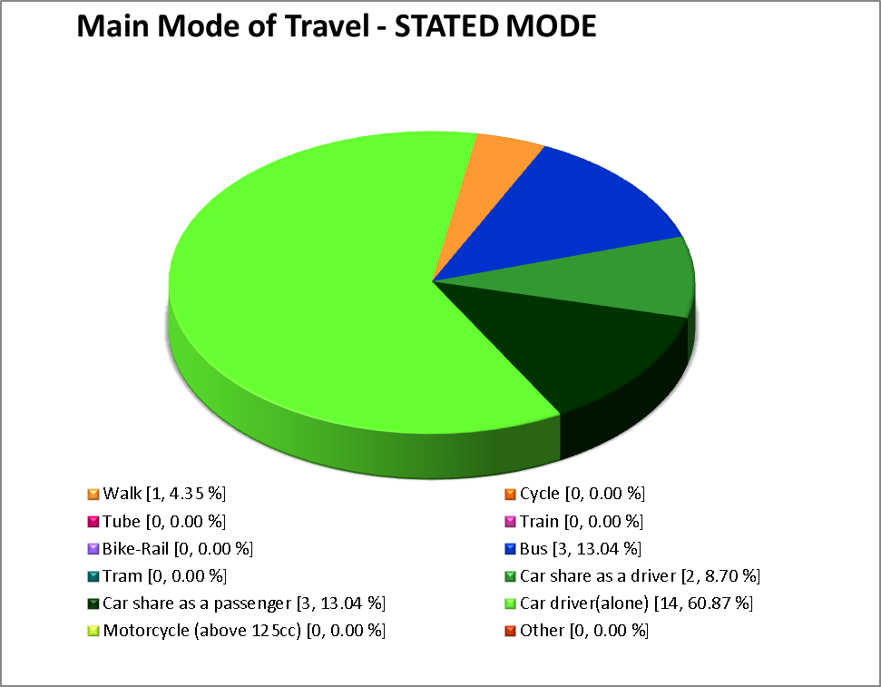

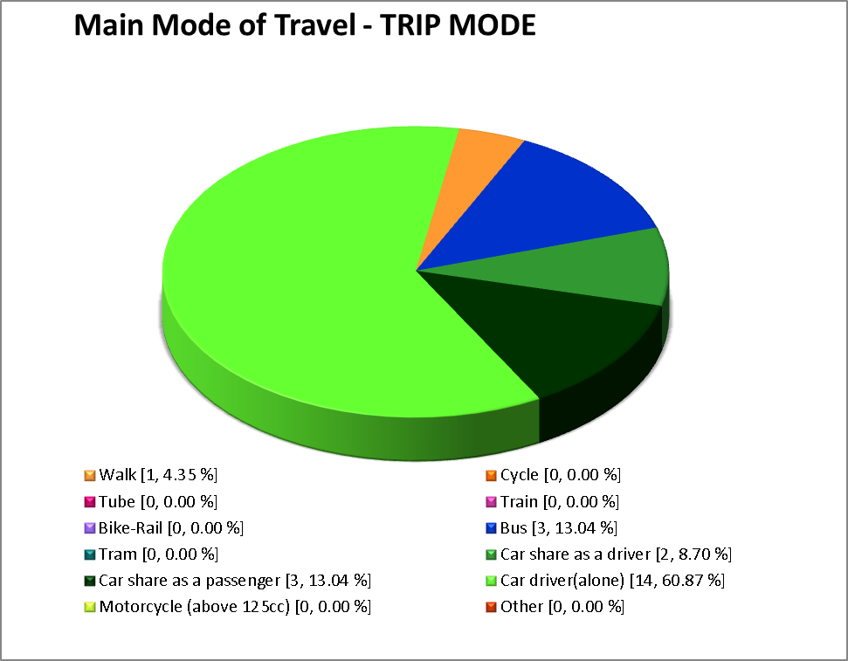
Chart 2.1: Main modes of travel to work

The results show that the levels of car useage is very high (over 80%) walking on foot is very low (less than 5%) and bus (around 13%).

Why staff travel in this way

Reasons for travelling by different modes can be useful in informing travel plan measures so we asked staff about their primary reason for using the type of transport that they travel using for the longest amount of time during their journey to work. A comprehensive summary of their responses can be found in Appendix 3 and particular points to note by mode are summarised below. Charts 2.2 show a summary of responses.

Charts 2.2: Reasons for using their main modes of travel

From Charts 2.2 it can be seen that the following reasons are highlighted by staff for using their main mode of travel:

                - Reasons for walking: convienience, Cost and health.
                - Reasons for travelling by car alone: convienience, time saving and availability

3.2% of respondents have a disability which affects their travel options and 0.0% are part of the blue badge scheme.

Where staff live

From the staff survey results, travel to work distances have been calculated. Chart 2.3 summarises the distances travelled to work by our staff.
Chart 2.3: Distances travelled by staff to this site

Peak arrival and departure times

The survey asked our staff about their normal times of arrival and departure from this site. We found that the peak staff arrival time is likely to be between 08:30 and 08:45. The peak departure time is likely to be between 22:00 and 22:15.

Car parking

Chart 2.4 indicates where our staff park when they commute to work by car. It shows that…
Complete with a few key findings, as appropriate.

Chart 2.4: Where staff park

How best to support public transport use?

We asked staff about what improvements they would most like to ideally see at our site or in the surrounding area to facilitate increased use of public transport. Staff were asked to rank different types of improvement on a scale of 1 to 4, with 1 indicating what they would most like to see. Chart 2.5 summarises the improvements which were ranked as the most important for encouraging public transport use.
Chart 2.5: Preferred measures for encouraging commuting by public transport

Chart 2.6 shows the number of respondents who favoured each measure, regardless of whether they ranked it as their top or bottom choice.

Chart 2.6: Supported measures for encouraging commuting by public transport.

How best to support active travel?

Similarly, we asked staff about what improvements they would most like to see at our site or in the surrounding area to facilitate walking or cycling. Chart 2.7 illustrates the improvements which were preferred for encouraging walking. Chart 2.8 shows those favoured to encourage cycling.

Chart 2.7: Preferred measures for encouraging walking
- Pirmeraly better lighting and security along with sohwers and safe crossing facilities would encourage more walking.

Chart 2.8: Preferred measures for encouraging cycling
- Secure parking would encourage more cycling along with lockers and changing facilities.

Supporting the use of other modes?

Finally, staff were asked about what would most support motorcycling or car sharing to work. Chart 2.9 shows their responses in relation to motorcycling and Chart 2.10 in relation to car sharing.

Chart 2.9: Favoured measures for supporting use of motorcycles
.

Chart 2.10: Favoured measures for supporting car sharing.
- Better incentives and finding of car share partners would encourage car sharing.

Relative support for measures to encourage different modes
- Better changing and showe facilities would have an impact on changing modes of travrel along with incentives and security.

Travel in the course of business

Our survey also explored travel within the course of our organisation’s business. Staff were asked how many days a month they travel for business. 23 staff report that they never travel for business or generally do so less than once a month.

Chart 2.3 is a scatter plot showing how often those who travel more frequently than once a month on business (8 staff) report doing so.

The most common response was that staff typically travel on business around 0 days a month. It can be seen that…
Chart 2.11: Typical frequency of business travel

The locations where our staff most commonly travel in the course of work are as follows:
                - HQ
                - Another site

Chart 2.12 shows the usual main mode of travel used by our staff to undertake journeys in the course of work.

Chart 2.12: Usual main modes of travel for business

It can be seen that driving a car alone is very high (80%), walking is (16%) bus is (4%)

Scope for a reduction in single occupancy trips

Staff who currently drive on business journeys were asked to indicate what could be done to encourage travel by another, more sustainable mode of transport. They were asked to tick up to four measures that they would support. Their responses are shown in Chart 2.13.

Chart 2.13: What could be done to reduce single occupancy business miles?
- Nothing much would change current opinion.

More specifically, staff were asked about whether they currently use certain ‘smarter’ working practices to reduce the need to travel to work or during the course of business. Their responses are set out in Table 2.3.
Table 2.3: Current use of and potential for ‘smarter’ working practices
Staff view | Practice/ measure
Staff view | Telephone conferencing |  | Video conferencing |  | Flexi-working |  | Compressed working week |  | Home working
Staff view | No | % | No | % | No | % | No | % | No | %
Currently do so | 0 | 0.0 % | 0 | 0.0 % | 0 | 0.0 % | 0 | 0.0 % | 0 | 0.0 %
Very realistic | 0 | 0.0 % | 0 | 0.0 % | 3 | 10.3 % | 0 | 0.0 % | 0 | 0.0 %
Possibly realistic | 0 | 0.0 % | 0 | 0.0 % | 2 | 6.9 % | 2 | 6.9 % | 1 | 3.4 %
Not realistic | 29 | 100.0 % | 29 | 100.0 % | 24 | 82.8 % | 27 | 93.1 % | 28 | 96.6 %

Question 15 of the staff survey also asked specifically about home working. Staff were asked about how interested they would be in doing so, should the opportunity be offered to them. Responses were as follows:
                - Very likely to want to work from home: 3.3 %.
                - Likely to want to work from home: 6.7 %.
                - Not likely to want to work from home: 6.7 %.
                - Not appropriate for my job: 83.3 %.

Due to the nature of the facility and the services we provide it is not realistic that home working, flexi time and a compressed working week will be possible for all staff.

Car based trips during the working day

Finally, we asked staff about whether they use their car for non-work purposes during the working day. This question only applied to those who arrive at or near to the site by car. 23 staff said that they do use their car for such purposes during the day.

Staff were then asked about which facilities they would use during the day, if they were available at or near the site. The implication is that this might reduce the need for car travel during the day. Responses are shown in Chart 2.14.

Chart 2.14: Facilities which would be used if they were available at or near the site.
Staff are not usually permitted to leave site during operational hours due to the nature of their work. However during exceptions some staff do use food retailers on site.
Some staff also use the gym however this is only done in their own leisure time not whilst on shift.

Visitor/patient/student/customer travel surveys

- None yet proposed.

Objectives, Targets and Indicators

Introduction

The sections below articulate the overarching objectives for our travel plan, as well as targets which we will seek to meet over the short and medium term. It includes indicators through which we will measure progress towards meeting our targets.

Objectives are the high-level aims of our travel plan. They give it direction and provide a focus.

Targets are the measurable goals by which we will assess our progress. We have set targets which we will seek to reach within the period covered by the current travel plan. In addition, we have set interim targets.

Indicators are the elements which will be measured in order to assess progress towards meeting the final and interim targets.

Our objectives, targets and indicators are set out below.

Objectives

Our objectives are:
            - Reduce single occupancy car travel.
            - Increase travel to site by bicycle.
            - Increase travel to site on foot.

Targets and indicators

Our targets and indicators are set out in Table 3.1.
Table 3.4: Our targets and indicators
No | Target | Comment/ Objective | Indicator | Baseline Value | Target Value(s) | % change | Measured by
‘Aim’ type targets
1 | Reduce single occupancy car travel |  | Less cars on car park |  |  | 20 | Questionaire
2 | Increase travel to site by bicycle |  | Increase in bikes on site |  |  | 10 | Questionaire
3 | Increase travel to site on foot |  |  |  |  | 10 | Questionaire
‘Action’ type targets

.

Travel Plan Strategy

Introduction
A travel plan strategy that sets out clearly the stages by which the travel plan will be developed and implemented is very important. Elements of a travel plan strategy usually relate to:
                - Securing the resources (including time) that are necessary to develop and implement the travel plan;
                - Consulting and educating staff; and
                - Identifying and engaging with partners.

Our strategy is set out within the remainder of this chapter. It discusses how our plan will be managed and marketed, as well as who our key partners will be.

Managing the plan: roles and responsibilities

Senior management support

Our travel plan has the support of senior management.

All travel plans are dependent on a nominated individual being given time and resources for success to occur. Rebecca Whittle is the person responsible for overseeing and implementing the various measures outlined in this travel plan. She will implimnet actions when time allows.

There is no travel plan steering group.

Our plan will be overseen by our senior managent and Wigan Council.

There are currently no external working groups who consult with the staff.

Partners and stakeholders

Travel plans need partnerships for success. Organisations/ developers need to work with a number of partners and internal stakeholders during the implementation process. It is expected that all partners will make an active contribution to the process.

Wigan Council assist with the implimemtation, including approval of new cycle storage areas.

Similarly, it is important that travel plans have the support of internal stakeholders, including the staff and other site users who stand to benefit from and be affected by the plan. Stakeholders are often engaged through a steering/reference group or through staff working or focus groups. Key stakeholders for our travel plan are:
                - Staff
                - Visitors
                - Customers
                - Students council
                - Trade unions
                - Human resources department
                - Finance department
                - Marketing department

Marketing

Marketing and awareness raising strategies form an important part of all travel plans. They cover both the involvement/ engagement of staff and awareness raising about travel options and the benefits of more sustainable or efficient travel.

Our travel plan will be marketed to:
                - Our management
                - Our staff
                - Our visitors
                - Our suppliers
                - The general public.

The primary means by which we will market our plan arr through notice boards and education staff and visitors to the centre.
.

Package of Measures for Employees

Introduction

The main core of a travel plan its package of measures, which can be comprised of a mixture of different kinds of actions, incentives and infrastructural improvements. Measures might be motivational, for awareness raising or for information provision. They could entail alterations to the way the organisation goes about its business (and to policies which dictate this). Finally, financial incentives or loans to remove barriers to sustainable travel might also feature.

This chapter sets out the package of measures which we will introduce in order to influence employee travel to/from our site, both for commuting and in the course of our business. Measures we have already introduced were discussed in Chapter 2.

Walking

Both cycling and walking are almost always encouraged within a Travel Plan. Walking is the most sustainable methods of travel, has a number of proven health benefits and is an important source of personal freedom. Walking is important for the vast majority of people, including those using public transport or without access to a car. It potentially has an important role to play in journeys to work, particularly for those living within two miles of their workplace. Walking is free and offers predictable journeys. Furthermore, it does not cause negative impacts in the same manner as vehicular travel (e.g. emissions, pollutants, severance etc). As for cycling, walking is a form of active travel, which can offer a range of physical and psychological benefits to the individual.

Cycling

Cycling is cheap, offers reliable journey times and is environmentally friendly. Within the workplace, encouragement of cycling can lead to a healthier, more productive work force.

A link has been identified between car growth and obesity, with both trends increasing at a similar rate between 1985 and 2000. Travel Plans can offer substantial health benefits to individuals who are motivated to complete more journeys on foot or by cycle. In turn, employers can benefit through increased productivity and reduced absence through illness.

Active travel is a means by which people can fit exercise into their busy lives and has been shown to have both physical and psychological benefits, including improved concentration upon arrival at their destination. The health benefits of cycling outweigh the risk of accidental death whilst cycling by a ratio of 20:1. A Travel Plan can offer benefits through the role of active travel in helping to: prevent diabetes, reduce the risk of colon cancer, prevent high blood pressure, decrease the risk of Coronary Heart Disease, control body weight, and prevent osteoporosis.

We will be encouraging, supporting and facilitating cycling to our site through the following measures.
Measures related to cycling to/from work. Some of the possible measures that might be applicable to your site could be:
                - Improvements to on-site and/or offsite cycle routes/lanes;
                - Changes to cycle parking – number; and/or
                - Changes to cycle parking – Quality (Sheffield stands to replace other kinds, lighting, CCTV, shelter, overlooked, location in relation to entrances);
                - Lockers/ storage
                - Showers
                - Cycle loan/tax free scheme for employees
                - Discounts on cycle and accessory purchases
                - Cycle training
                - Marketing of cycling (e.g. health aspects).

Public transport access

Increased use of public transport is a fundamental aspect of the Government’s sustainable transport strategy. The benefits of travelling by public transport can include:
                - No need to park.
                - Traffic free routes (with rail or bus priority existing);
                - Being able to relax, read or work (particularly for business travel during the day).

It is important to recognise that, where possible, walking and cycling are usually favourable to public transport because they have fewer environmental impacts and offer health benefits. Nevertheless, public transport remains important, particularly for journeys to work of more than 5 miles (8km).

The sections below highlight the measures which we propose to introduce to encourage and support the use of public transport for commuting to our site and for business travel.

Bus
Measures related to maintaining/improving bus access to the site. Some of the possible measures that might be applicable to your site could be:
        - Improvements to bus services/stop facilities at/for your site (or contributions towards these) – for example, think about quality of stops (lit, CCTV, shelters, seats, timetables/live travel info, cleanliness;
        - Specific cost incentives (rail/bus subsidies/loans/taster tickets);
        - Specific marketing initiatives;
        - Improvements to pedestrian linkages to the nearest bus stop(s) (referring back to previous section where necessary).

Surface Rail
Measures related to maintaining/improving surface rail access to the site. Some of the possible measures that might be applicable to your site could be:
        - Contributions towards service or station improvements;
        - Specific cost incentives (rail/bus subsidies/loans/taster tickets);
        - Specific marketing;
        - Improved pedestrian/cycle linkages to closest surface rail station(s).

Park And Ride
Measures related to maintaining/improving park and ride access to the site. Some of the possible measures that might be applicable to your site could be:
        - Improvements to park and ride bus services/stop facilities at/for your site (or contributions towards these) – for example, think about quality of stops (lit, CCTV, shelters, seats, timetables/live travel info, cleanliness;
        - Specific cost incentives (rail/bus subsidies/loans/taster tickets);
        - Specific marketing initiatives;
        - Improvements to pedestrian linkages to the nearest park and ride bus stop(s) (referring back to previous section where necessary).
Consider: will park and ride be an option for travel to your site in the future?

Managing car use

It is important that car use and parking are managed in association with a travel plan. Sometimes this is necessary to alleviate problems of parking stress on or around a site, perhaps as the result of increased demand arising from a new development proposal. Better management can help to ensure more efficient and equitable use of spaces, particularly since parking is usually a subsidised resource (the provision and maintenance costs of which are often not borne or fully borne by staff). Our proposals for encouraging more efficient car use for commuting to our site are set out below.

Car Parking
The importance of car park management and associated considerations. It is recommended that you also highlight the importance of car parking in your text for this section.
Outline any proposals to change car parking arrangements either in terms of numbers, charges or enforcement. Use appropriate sub-headings (e.g. car park management plan). Below is a list of some of the typical aspects of car parking arrangements that you might be changing in association with your travel plan:
        - Number of spaces;
        - Allocation of spaces (e.g. staff, visitors, disabled, parent and child, limited wait, pick-up/drop off only);
        - Management of spaces (e.g. first come, first served; permit for allocated spaces; permits for license to hunt etc.);
        - Is the allocation
              - Needs based?
              - Free for all?
              - According to grade?
              - Allocated space?
        - Essential car user definition (if appropriate);
        - Parking charges for different types of user;
        - Operation of the parking (e.g. pay and display, deductions from salary, pay on foot, attendant, other);
        - Enforcement arrangements (e.g. barrier, external security firm, own security, other);
        - Quality of parking areas (signage, lighting, security/CCTV);
        - Any proposals to reduce off-site/overspill parking if currently an issue;
        - Any other arrangements.

Car Sharing

‘Car Sharing’ refers to a situation where two or more people travel by car together, for all or part of the car trip.

Car sharing is when two or more people share a car and travel together. One of the people travelling is usually the owner of the vehicle and the others usually make a contribution towards fuel costs. It allows people to benefit from the convenience of the car, whilst alleviating the associated problems of congestion and pollution.
To introducing a car sharing scheme and/or to make changes to or to continue to operate current scheme you have. You might want to outline:
        - How it will operate/ matching will occur;
        - Who will be responsible for overseeing/administering the scheme;
        - Any supporting measures such as preferential parking of any form/ Guaranteed ride home – the latter is considered an essential element;
        - How it will be launched and/or marketed to staff.

Car Club

‘Car Club’ is the common term for arrangements which give access to a pool of cars or other light vehicles to members for flexible periods of time (as required by the user) and at rates lower than conventional car hire. Members might pay an annual subscription to the car club’s operator and then pay a charge each time the use a vehicle. Alternatively, costs may be charged entirely on a ‘pay as you go’ basis. The charge is typically based on the length of the booking and/or the mileage travelled.

Powered two wheelers

Powered two wheelers have both benefits and disadvantages as compared to travel by private car and by more sustainable modes. As a result, they do not always feature within a travel plan and greater effort is generally expended promoting other, more sustainable modes.

One issue with powered two wheelers is that motorcycle casualty rates are substantially higher than for other forms of road transport. In addition, motorcycles can generate relatively more pollution and noise than private cars and other forms of transport. More positively, motorcycles, mopeds and scooters can offer quick, relatively low cost private transport and are more space and fuel efficient than cars.

Reducing the need to travel

A good travel plan looks beyond opportunities for modal shift towards lower impact modes and incorporates a review of the overall operation of the organisation to identify means by which it is possible to improve efficiency and to reduce the need to travel overall, particularly by car. This section summarises the measures which we will introduce to reduce the need to travel both to our site and also in the course of work.

Recruitment And Relocation
There is no policy to recruit localy and there are no relocation costs provided.

Reducing The Need To Travel To Work
There is no opertunity to reduce the need to travel to work as the site needs to be staffed to provide adequate cover for health and safety reasons.
Travel during the working day

We can limit travel during the working day with the following:
Hot Desking – if a member of staff from another site attends a meeting they can acces a computer terminal to their personal files, reducing the need to travel to their own site for documents.

Business travel

The following section sets out measures by which we will seek to reduce car use for business purposes.

Policy

Staff can claim milage for their journey. They also try to car share if traveling to meetings.

Fleet Vehicles
We only have one shared van which all sites can use Only staff who are on the companys insurance can drive the van.

Cycling
A quarter of all car trips in the UK are less than 2 miles long, but catalytic converters that cut down a car’s carbon dioxide emissions only start working after you have driven two miles.
How many people drive to then work out in the gym? Customers might be encouraged to use their bike if secre, cycle parking is available.
WLCT have a cycle to work scheme which includes a loan bike and safety equipment to help staff and encourage them to use a bike to travel to work.

By Motorcycle

No expencies can be claimed for milage or cycling gear.

Deliveries and servicing

Transport impacts on a site are not only related to commuting and business travel, but can also arise through arrangements for deliveries and servicing. This section summarises our proposals for managing servicing requirements at our site.
Outline any measures/proposals related to reducing the impact or number of deliveries. For example, local sourcing, scheduling times etc. Food, cleaning and chemical, equipment and event deliveries.

Travel information and planning

Complete and easy to understand information about travel information is an essential ingredient for a travel plan, since the first step towards behavioural change is for an individual to understand and consider the options which are realistically available to them and the benefits and disadvantages of each. One barrier to behavioural change is not knowing about these options. Equally, it is unrealistic to expect behavioural change where there are no viable alternatives. This is why baseline surveys and assessments are important elements in the travel planning process.

This section summarises the measures which we will introduce to disseminate travel options information and to facilitate the planning of commuting and business journeys.

For New Recruits

All information for new starters can be found in their induction pack.

For All Staff/ Site Users

All staff can find nformation on travel both on noticiboards and by asking management or reading the travel plan.

Measures for

Introduction

Travel information including bus timetables and cycle routes are displayed for customers on site on specific noticeboards.

Showers and changing facilities including lockers are provide for people who walk or cycle o the centre.

Monitoring and Review

Introduction

Our travel plan is a continuous process for improvement, requiring monitoring, review and revision to ensure it remains relevant to our organisation and those using this site. This documents sets out our proposals for monitoring and review of the travel plan over the next 5 years.

In line with iTRACE monitoring procedures, we will undertake monitoring of our travel survey every year. In year five, or perhaps sooner if the need arises, we will review our travel plan and targets and will set new objectives, targets and measures where appropriate.

This section sets out the specific monitoring proposals associated with our site and the means by which we will assess progress towards our targets.

Monitoring plan

Table 7.5 summarises our monitoring plan, including the data collection activities which will be undertaken and when these will occur. Specific types of information/ indicators which will be measured through each activity (see Chapter 3) are also identified.
Table 7.5: Monitoring plan
Data collection exercise | Key information | When/ how frequently | By whom | Comments
Baseline staff travel survey | Staff travel for commuting, business travel etc… | Already completed (October 2015) | Travel Plan-co-ordinator using iTRACE | Completed

Reporting

The results of our travel surveys and of any review of the travel plan will be reported to the local authority through iTRACE. This is usually completed annually.

As appropriate, we will also disseminate key survey and/or monitoring findings amongst our staff.

Action Plan

Introduction

This chapter draws together our proposals for travel plan implementation, monitoring and review. The actions which we will take are summarised in our action plan, which indicates how the various elements of the plan will be drawn together and how we will prioritise our actions.

Action Plan

Table 8.6 contains our action plan.

This travel paln is within the sites ISO14001 environmental action plan.
Table 8.6: Action Plan
When | Activity | By whom
May 2016 | New cycle storage | R. Whittle
November 2016 | Staff travel survey | R. Whittle
Monthly | Update travel noticeboards to encourage alternative transport | R. Whittle

Appendix 1 - Policy context

National Policy

The Government has established the need to reduce car dependency and increase travel choices through key guidance in the Transport White Paper, Road Traffic Reduction Act and the Planning Policy Guidance 13 (Transport). Of these, Planning Policy Guidance 13 (PPG 13), provides the strongest imperative for travel plans and any arising planning obligation. It recommends travel plans for various land uses, including places of work.

PPG13 (Transport) 2001 indicates that travel plans should be submitted alongside major planning applications, developments likely to generate a significant amount of traffic, or to generate traffic in sensitive locations (e.g. Air Quality Management Areas). They should help to deliver:
            - reductions in car usage (particularly single occupancy journeys) and increased use of public transport, walking and cycling;
            - reduced traffic speeds and improved road safety and personal security particularly for pedestrians and cyclists; and
            - more environmentally friendly delivery and freight movements, including home delivery services.

Travel plans, or elements from them, are often secured by a planning condition or agreement. Information on planning obligations secured under Section 106 of the Town and Country Planning Act (1990) can be found in Circular 05/2005 published by the Office Of The Deputy Prime Minister (ODPM). The ODPM is now the Department for Communities and Local Government.

Appendix 2 - Staff travel survey results 2015 Summary of Staff Travel Survey Findings
This document sets out a summary of key findings from a staff travel survey undertaken for the following site, using the iTRACE Workplace Travel Plan Tool:
Site Postcode: WN7 4JY
Site ID: Leigh Sports Centre - Leigh Sports Centre, Sale Way, WN7 4JY - 6
Survey undertaken: 14/10/2015 - 25/11/2015
Please note that lists of ‘other’ text responses to questions are available to the Site Coordinator as a separate output file.

Response rate and demographics
Number of staff issued a questionnaire: 0
Response: 23
Response Rate: 0

Number of staff usually travelling to work

Where do staff usually work (normal journey to work)?
Location | Frequency of response | Percentage
Home work station
‘My Place of Work’ | 23 | 100.0 %
Another location

Mode from home:

Mode
Main mode:
Note: Main mode = mode used for longest total time within journey.
Journey legs:
Number of legs | Frequency of Response | Percentage
1 | 20 | 87.0 %
2 | 1 | 4.3 %
3 | 2 | 8.7 %
4
5

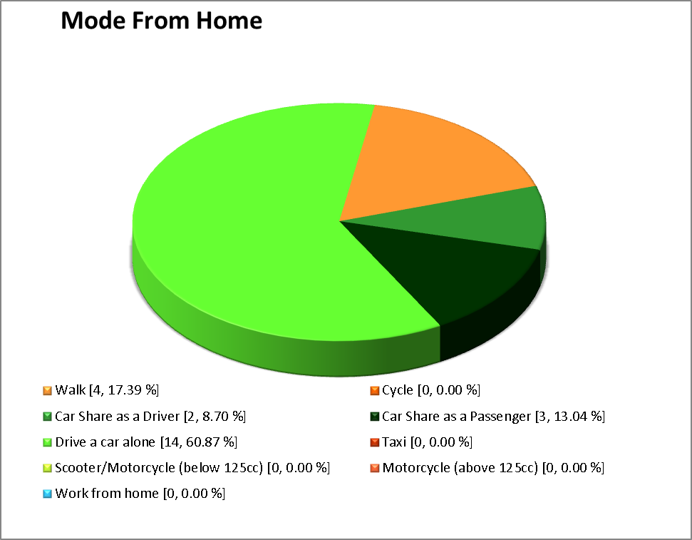

Mode of arrival at our site:
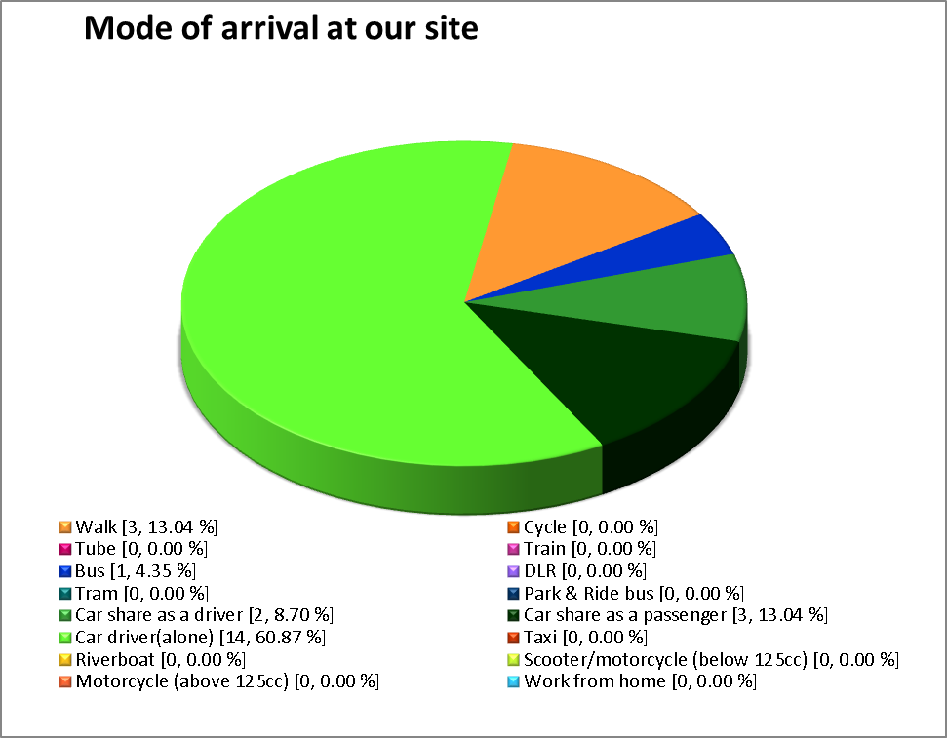

Penultimate mode of arrival:
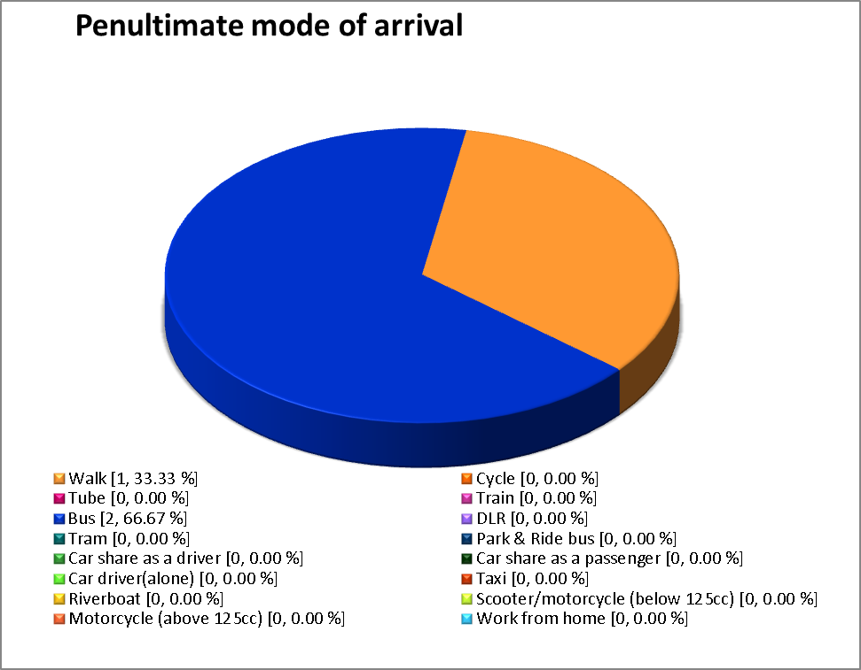

Appendix 3 - Staff travel survey results 2014

Summary of Staff Travel Survey Findings
This document sets out a summary of key findings from a staff travel survey undertaken for the following site, using the iTRACE Workplace Travel Plan Tool:
Site Postcode: WN7 4JY
Site ID: Leigh Sports Centre - Leigh Sports Centre, Sale Way, WN7 4JY - 6
Survey undertaken: 17/09/2014 - 20/10/2014
Please note that lists of ‘other’ text responses to questions are available to the Site Coordinator as a separate output file.

Response rate and demographics
Number of staff issued a questionnaire: 29
Response: 25
Response Rate: 86.2 %

Number of staff usually travelling to work

Where do staff usually work (normal journey to work)?
Location | Frequency of response | Percentage
Home work station
‘My Place of Work’ | 25 | 100.0 %
Another location

Mode from home:

Mode
Main mode:
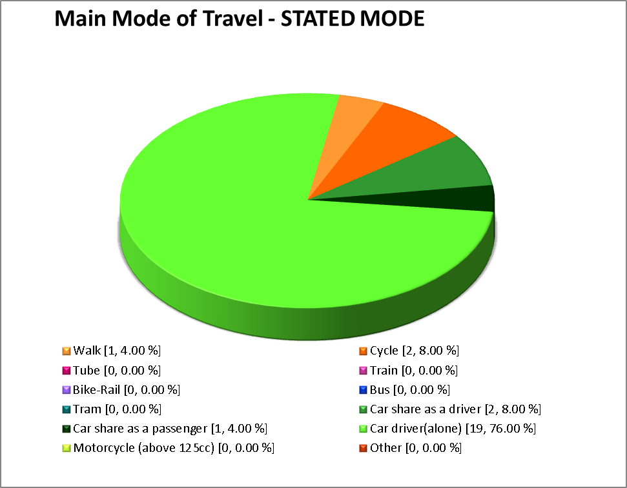
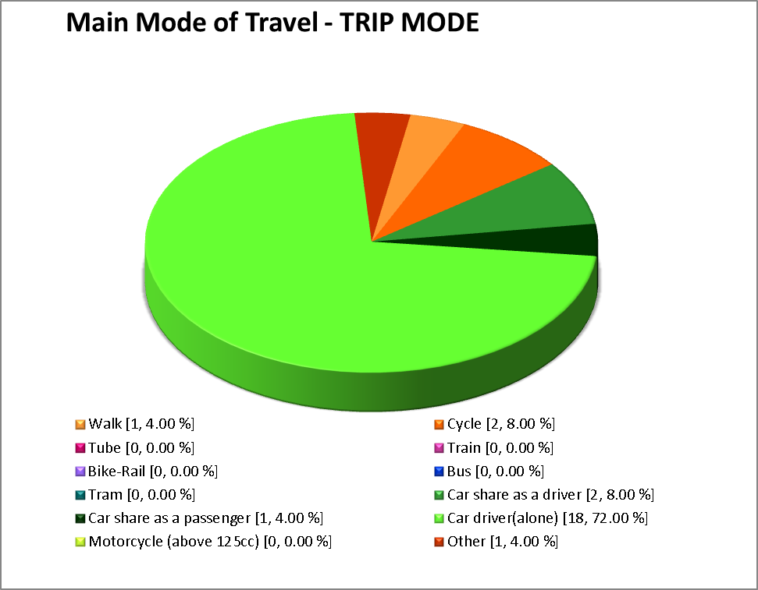
Note: Main mode = mode used for longest total time within journey.
Journey legs:
Number of legs | Frequency of Response | Percentage
1 | 25 | 100.0 %
2
3
4
5

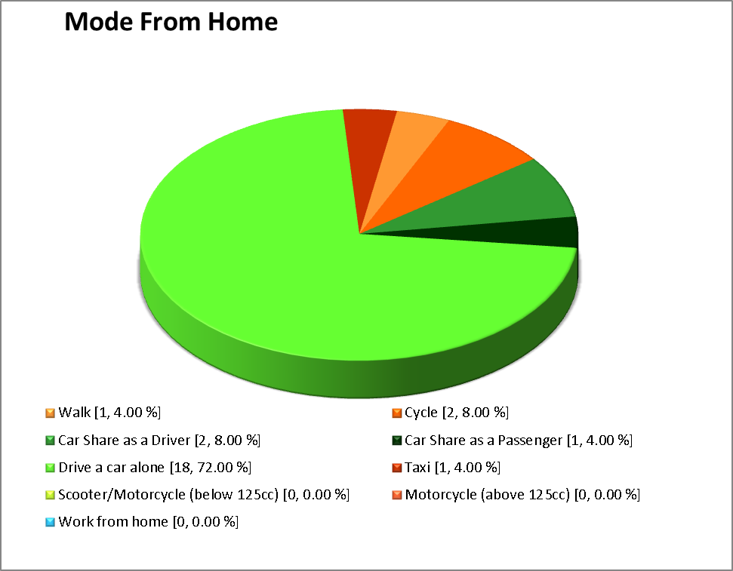
Mode of arrival at our site:
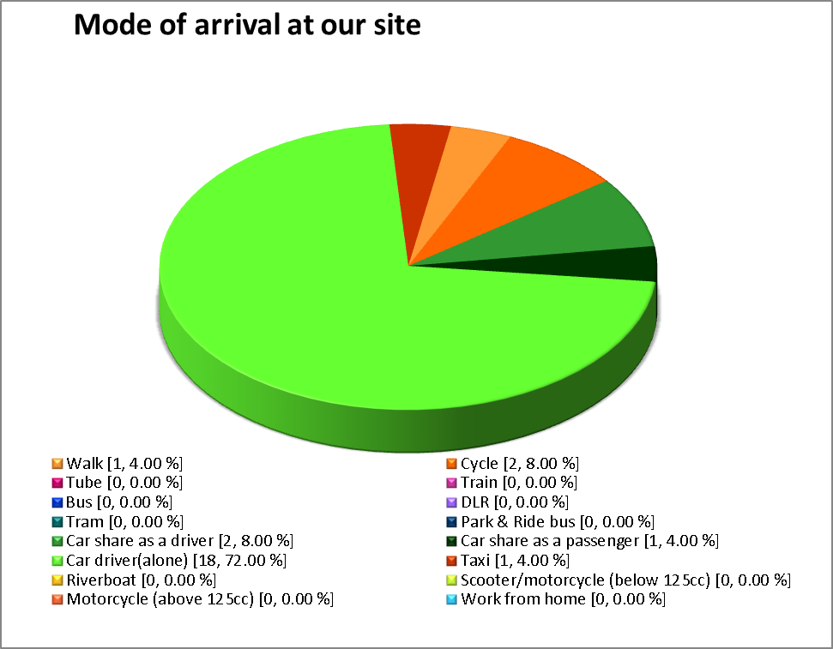
Penultimate mode of arrival:
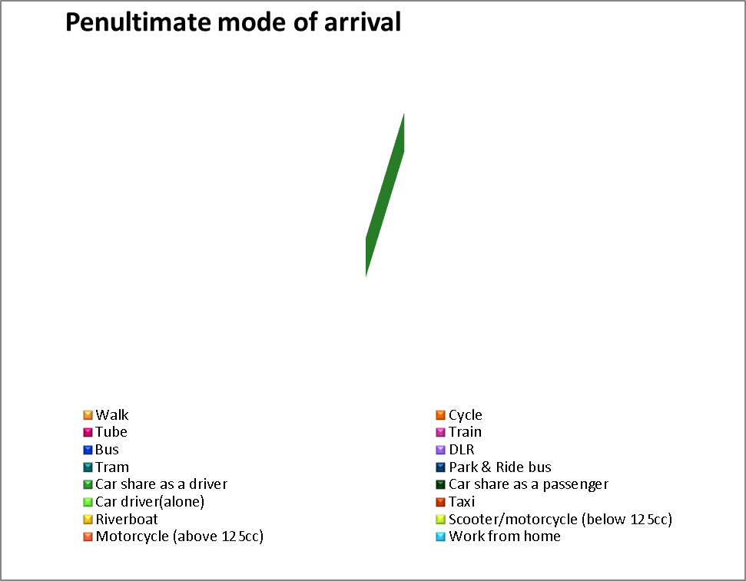

Appendix 4 - Staff travel survey results 2011

Summary of Staff Travel Survey Findings
This document sets out a summary of key findings from a staff travel survey undertaken for the following site, using the iTRACE Workplace Travel Plan Tool:
Site Postcode: WN7 4JY
Site ID: Leigh Sports Centre - Leigh Sports Centre, Sale Way, WN7 4JY - 6
Survey undertaken: 20/04/2011 - 21/04/2011
Please note that lists of ‘other’ text responses to questions are available to the Site Coordinator as a separate output file.

Response rate and demographics
Number of staff issued a questionnaire: 31
Response: 31
Response Rate: 100.0 %

Q20: Please indicate your gender
Gender | Frequency of Response | Percentage of total | Percentage of responses
Male | 15 | 48.4 % | 48.4 %
Female | 16 | 51.6 % | 51.6 %
Unspecified | 0 | 0.0 %
Total: | 31

Q21: Please indicate your age group
Age | Frequency of Response | Percentage of total | Percentage of responses
16-18: | 0 | 0.0 % | 0.0 %
19-21: | 6 | 19.4 % | 19.4 %
22-24: | 12 | 38.7 % | 38.7 %
25-30: | 6 | 19.4 % | 19.4 %
31-35: | 4 | 12.9 % | 12.9 %
36-40: | 1 | 3.2 % | 3.2 %
41-50: | 1 | 3.2 % | 3.2 %
51-60: | 1 | 3.2 % | 3.2 %
61-70: | 0 | 0.0 % | 0.0 %
71+: | 0 | 0.0 % | 0.0 %
Unspecified | 0 | 0.0 %
Total: | 31

Number of staff usually travelling to work

Where do staff usually work (normal journey to work)?
Location | Frequency of response | Percentage
Home work station
‘My Place of Work’ | 31 | 100.0 %
Another location

Mode from home:

Mode
Main mode:
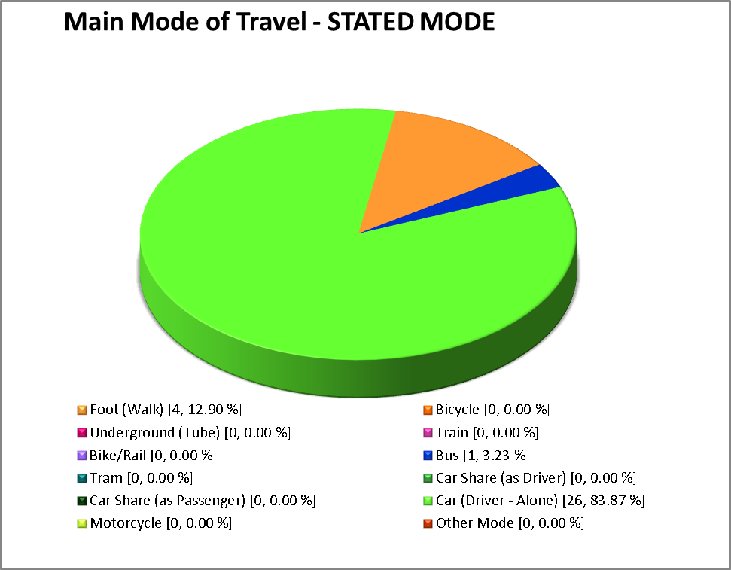
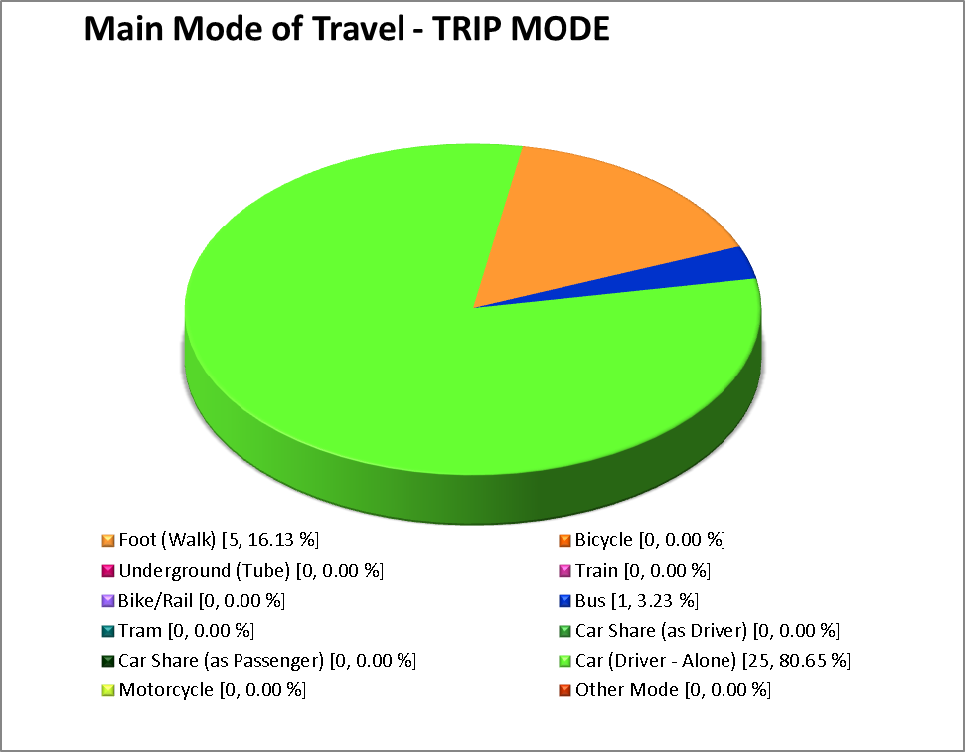
Note: Main mode = mode used for longest total time within journey.
Journey legs:
Number of legs | Frequency of Response | Percentage
1 | 28 | 90.3 %
2 | 2 | 6.5 %
3 | 1 | 3.2 %
4
5

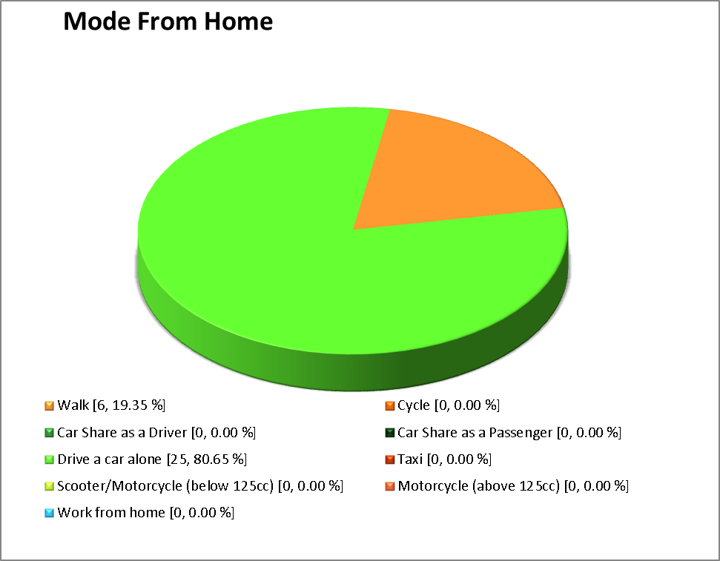
Mode of arrival at our site:
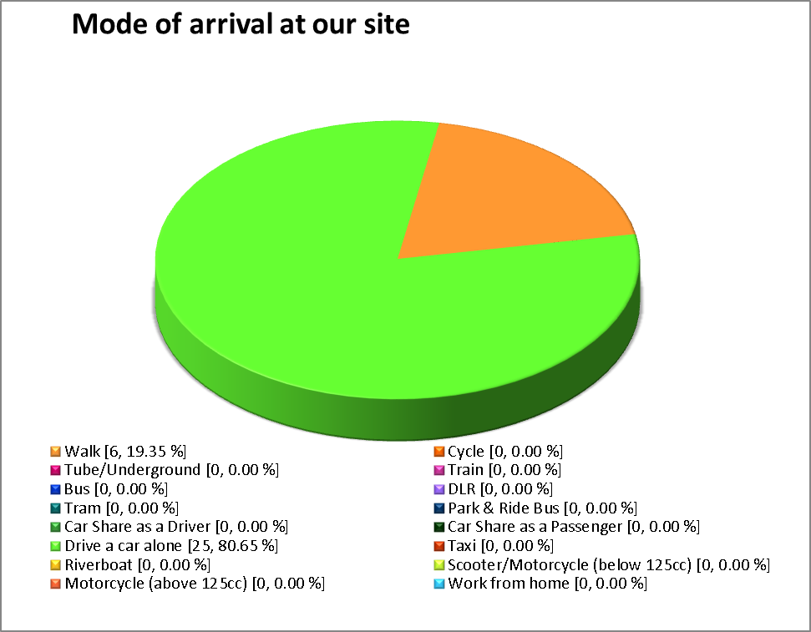
Penultimate mode of arrival:
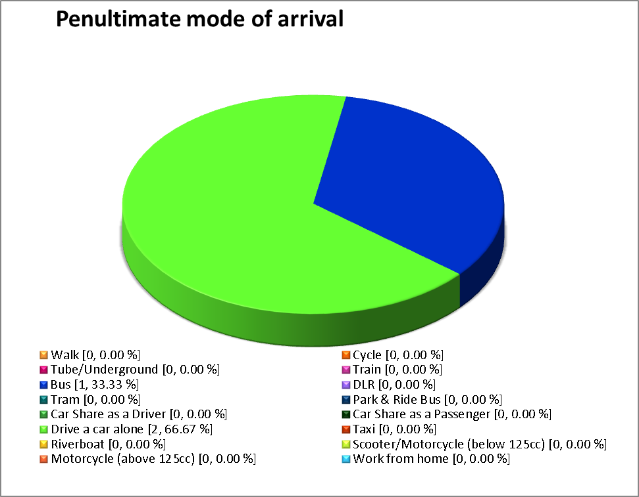

Reasons for mode choice

Q6: Why do you use this mode of travel? [Main Mode].
Main Mode = most time spent overall during journey.
1) Working from home
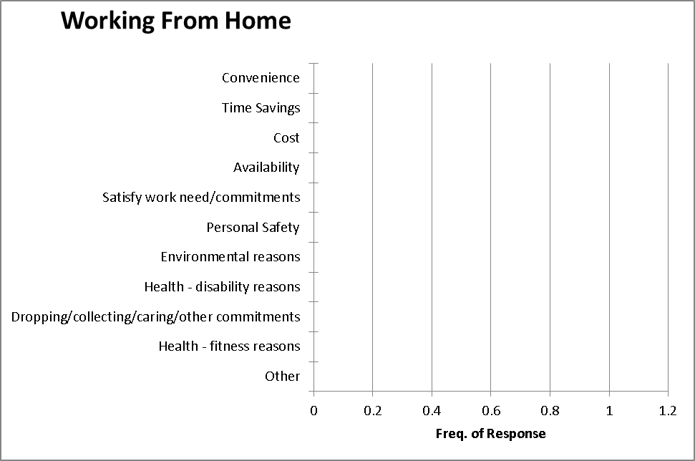
2) Active modes
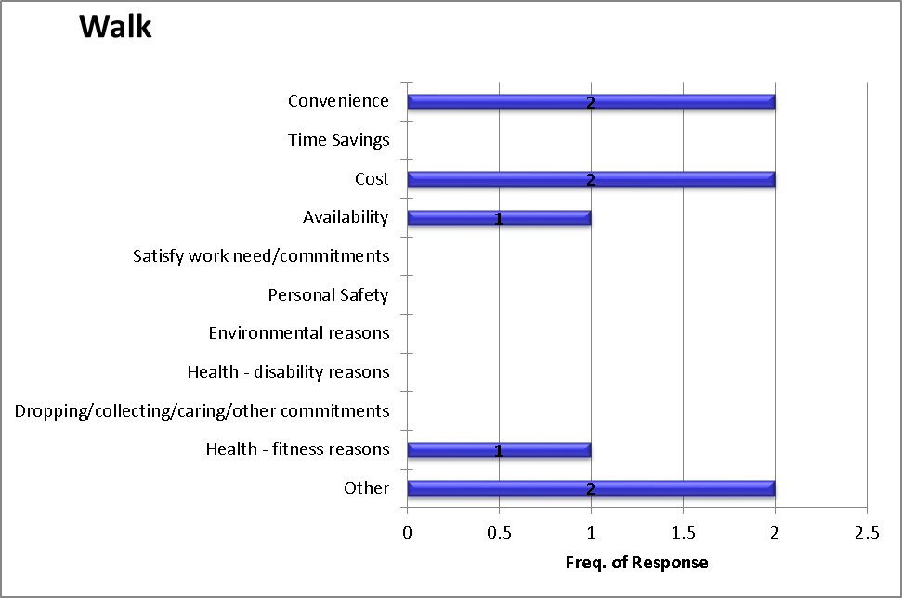
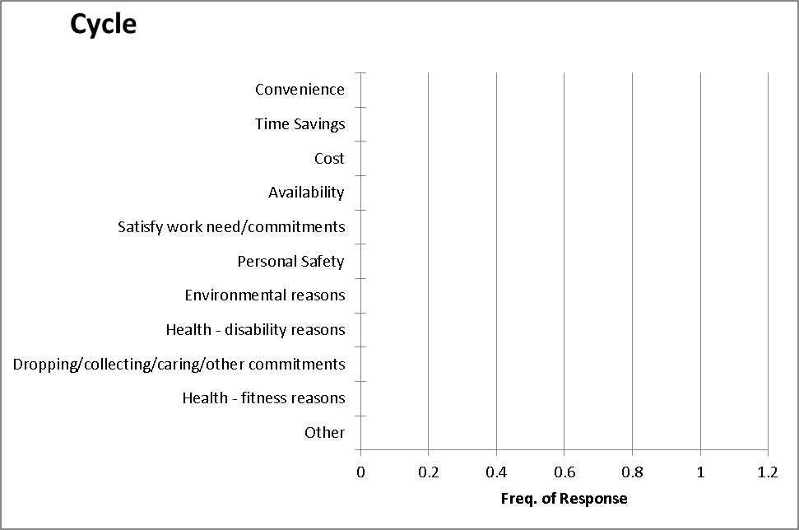
3) Powered two wheelers
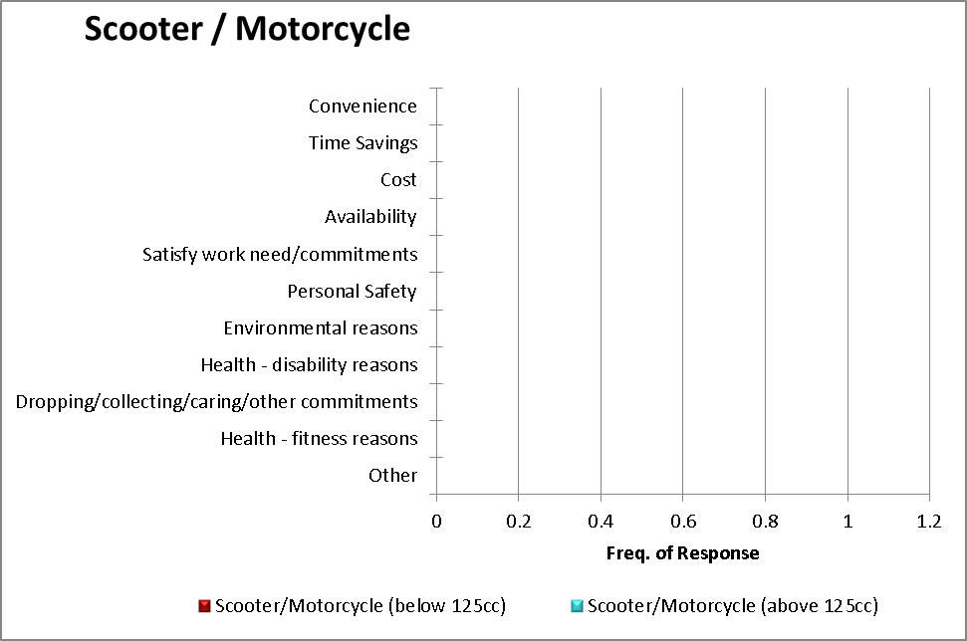
4) Car based modes
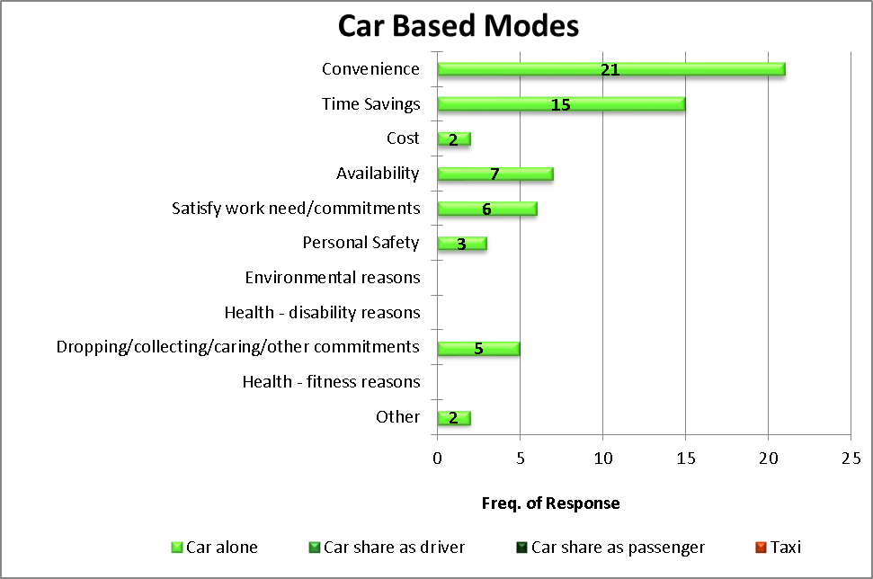
5) Surface public transport
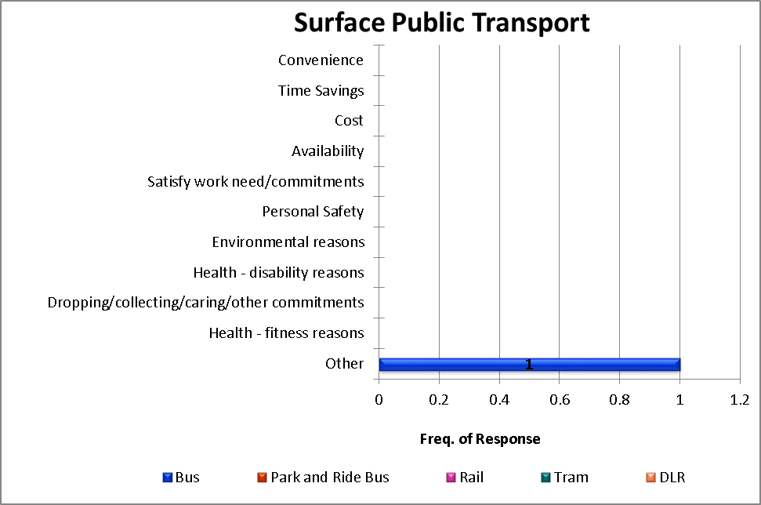
6) Other public transport
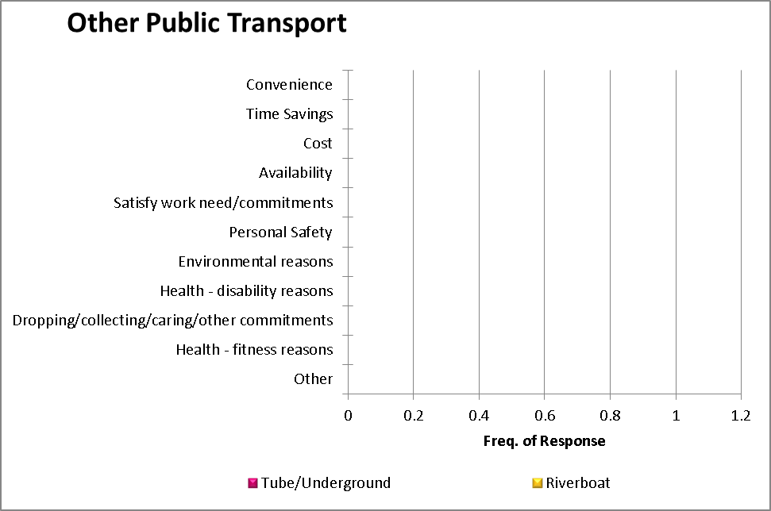

Disability as a barrier to travel options?

Q3: Do you have a disability that would affect your travel options?
Response | Frequency of Response | Percentage of total | Percentage of responses
Yes | 1 | 3.2 % | 3.2 %
No | 30 | 96.8 % | 96.8 %
Unspecified
Total: | 31

If yes to Q3 only:

Q4: Are you part of the Blue Badge Scheme?
Response | Frequency of Response | Percentage of total | Percentage of responses
Yes
No | 1 | 100.0 % | 100.0 %
Unspecified (of those who said Yes to Q3)
Total: | 1

Parking

Q7a: Do you drive or car share for part or your entire journey to work?
Response | Frequency of Response | Percentage of total
Yes | 23 | 74.2 %
No | 8 | 25.8 %
Total: | 31

Q7b: When you drive or car share to work, where do you park?
Response | Frequency of Response | Percentage of total | Percentage of responses
On-site car park (no parking charges) | 23 | 100.0 % | 100.0 %
On-site car park (parking charges)
Public car park (off-site)
On-street parking (no parking charges)
On-street car park (parking charges)
Park and ride site
Not applicable – I am dropped off
Other
Unspecified
Total | 23

Working Patterns/Status

Q2: Please select one choice from the following options which best describes your current working status.
Response | Frequency of Response | Percentage of total | Percentage of responses
Permanent | 26 | 83.9 % | 83.9 %
Contract
Agency
Casual Seasonal | 5 | 16.1 % | 16.1 %
Unspecified
Total | 31

Q1b: I work Full Time (FT)/ Part Time (PT).
Works | Frequency of Response | Percentage of total | Percentage of responses
Full time | 18 | 58.1 % | 58.1 %
Part time | 13 | 41.9 % | 58.1 %
Unspecified
Total | 31

Q1c: I work rotational shifts (Y/N)
Works | Frequency of Response | Percentage of total | Percentage of responses
Yes | 29 | 31 | 93.5 %
No | 2 | 6.5 % | 93.5 %
Unspecified
Total | 31

Q1a: On an average week what time do you usually arrive and leave work? (Use 24 Hour Clock)
Number of days a week worked during a typical week.
Number of days | Frequency of Response | Percentage of responses
1
2 | 2 | 6.5 %
3 | 5 | 16.1 %
4 | 5 | 16.1 %
5 | 11 | 35.5 %
6
7 | 8 | 25.8 %

Staff usually work:
Day | Frequency of Response | Percentage of responses
Monday | 28 | 18.7 %
Tuesday | 24 | 16.0 %
Wednesday | 26 | 17.3 %
Thursday | 21 | 14.0 %
Friday | 19 | 12.7 %
Saturday | 18 | 12.0 %
Sunday | 14 | 9.3 %

Staff most commonly arrive at the site*
Time | Frequency of Response
00:00 - 01:00
01:00 - 02:00
02:00 - 03:00
03:00 - 04:00
04:00 - 05:00
05:00 - 06:00
06:00 - 07:00
07:00 - 07:15 | 18
07:15 - 07:30 | 4
07:30 - 07:45 | 9
07:45 - 08:00 | 1
08:00 - 08:15 | 11
08:15 - 08:30
08:30 - 08:45 | 19
08:45 - 09:00 | 12
09:00 - 09:15 | 7
09:15 - 09:30
09:30 - 09:45
09:45 - 10:00
10:00 - 10:15 | 2
10:15 - 10:30
10:30 - 10:45
10:45 - 11:00
11:00 - 11:15 | 1
11:15 - 11:30
11:30 - 11:45 | 2
11:45 - 12:00
12:00 - 12:15 | 4
12:15 - 12:30
12:30 - 12:45 | 1
12:45 - 13:00
13:00 - 13:15 | 2
13:15 - 13:30
13:30 - 13:45 | 2
13:45 - 14:00 | 1
14:00 - 14:15 | 18
14:15 - 14:30 | 3
14:30 - 14:45
14:45 - 15:00 | 4
15:00 - 15:15 | 5
15:15 - 15:30 | 7
15:30 - 15:45
15:45 - 16:00 | 7
16:00 - 16:15 | 3
16:15 - 16:30
16:30 - 16:45
16:45 - 17:00
17:00 - 17:15 | 1
17:15 - 17:30
17:30 - 17:45 | 1
17:45 - 18:00
18:00 - 18:15 | 1
18:15 - 18:30
18:30 - 18:45
18:45 - 19:00
19:00 - 20:00 | 2
20:00 - 21:00 | 2
21:00 - 22:00
22:00 - 23:00
23:00 - 00:00

*Response takes account of responses for each and every day of the week, so if most staff travel onto the site on weekdays, the normal arrival time is probably the most common arrival time for a weekday. Similarly, if most staff travel to work at the weekend, the opposite will be true.

Encouraging the use of alternatives
1) Preferred Measures for encouraging commuting by public transport:
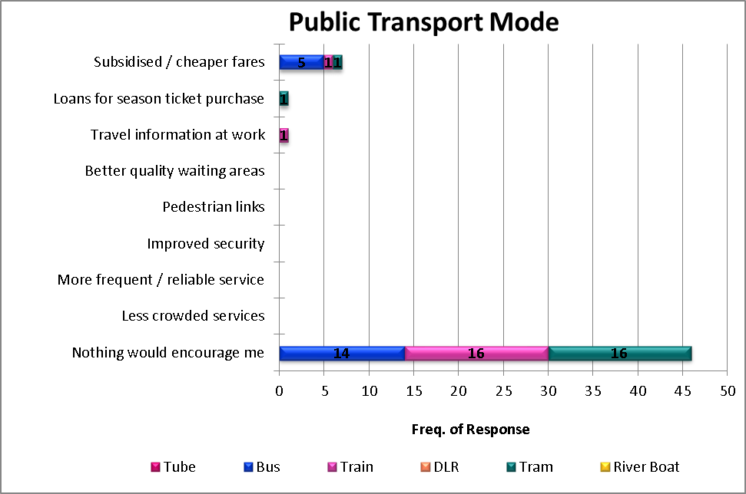
2) Supported measures for encouraging commuting by public transport:
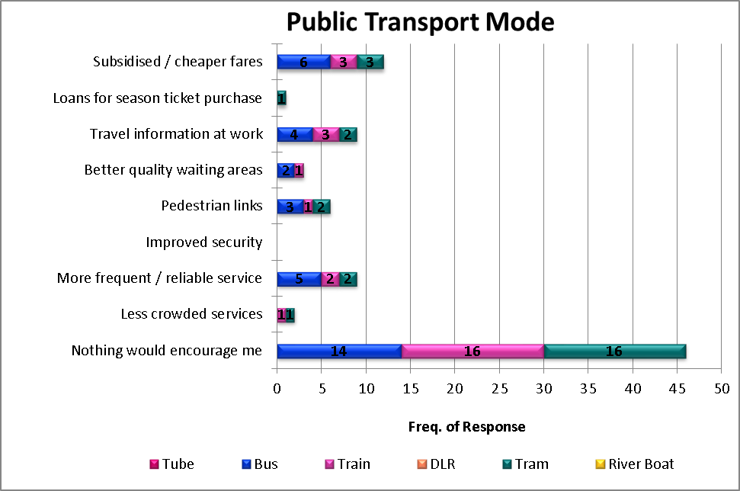
3) Preferred and supported measures for encouraging walking:
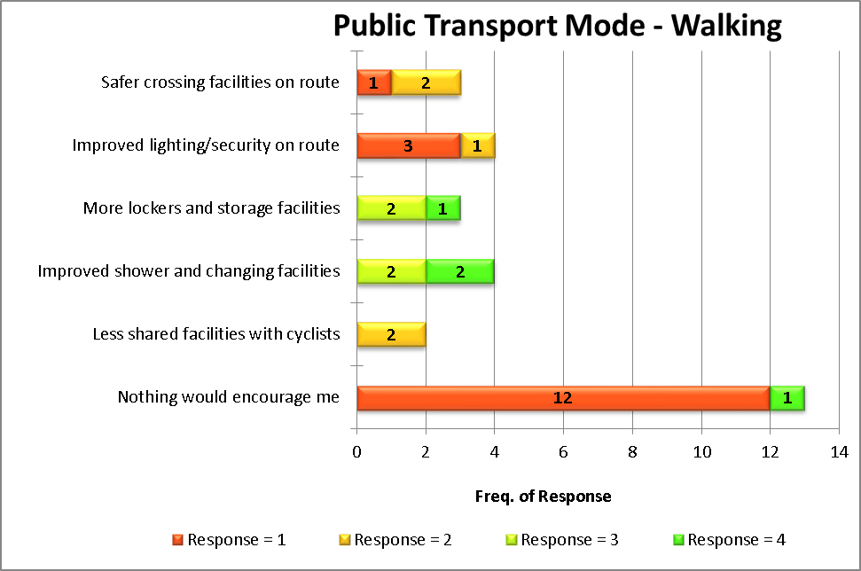
4) Preferred and supported measures for encouraging cycling:
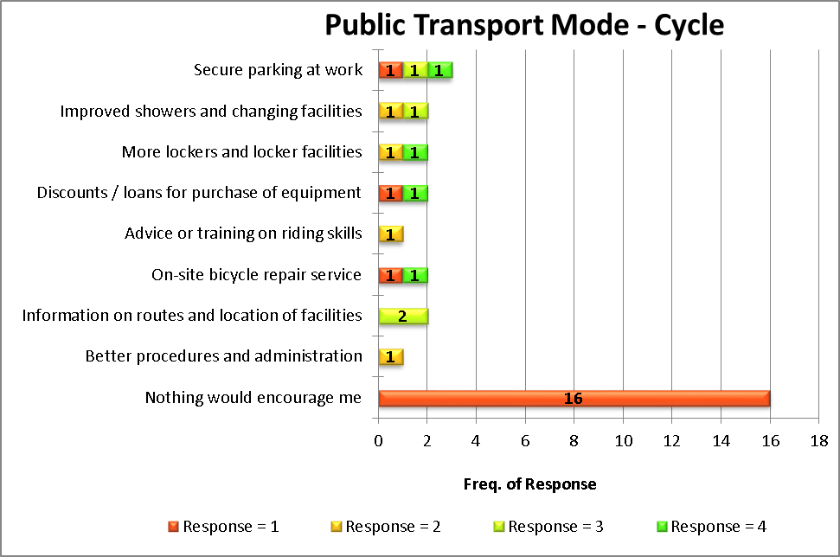
5) Preferred and supported measures for encouraging the use of motorcycles
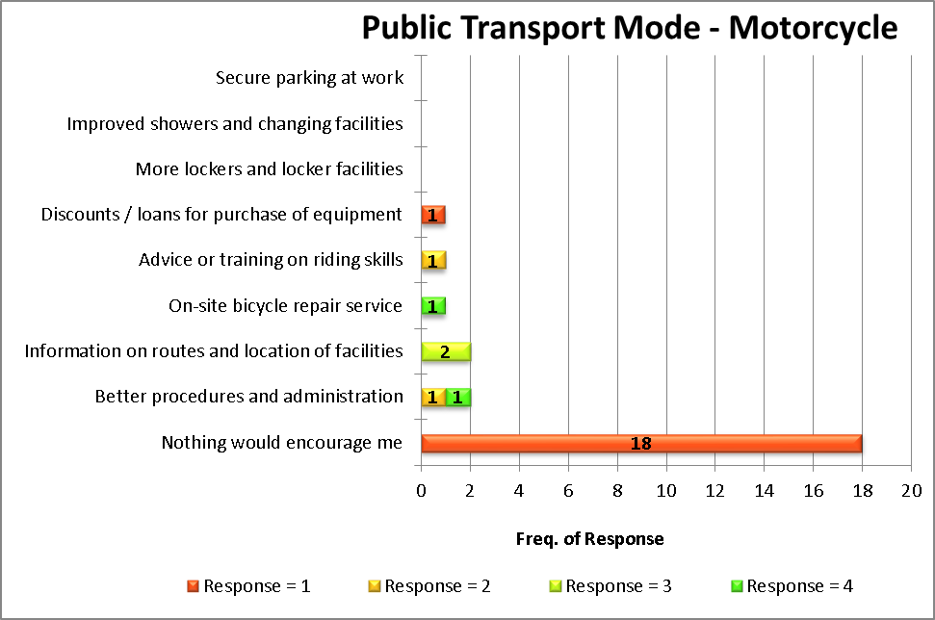
6) Preferred and supported measures for encouraging car sharing.
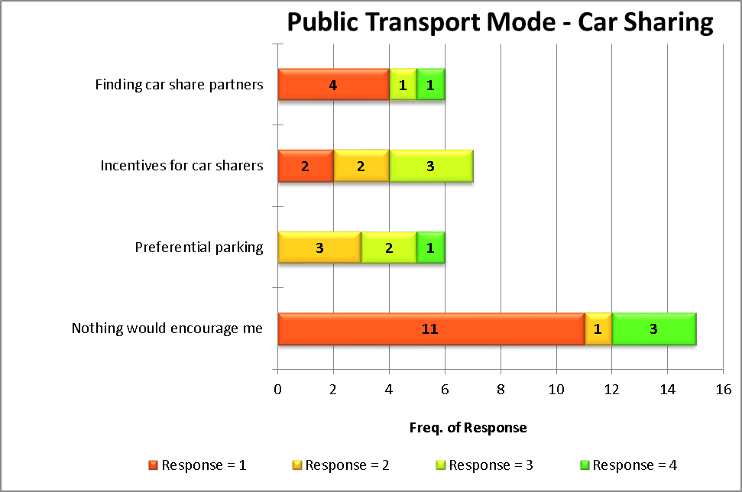

Travelling in the course of work
Number of staff who typically travel for work once a month or more often:
Typical frequency of business travel (days per month):
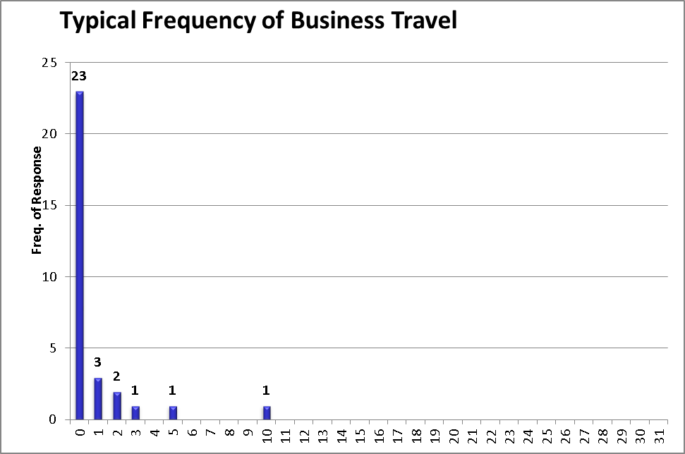

Q10: Where do you usually travel on business?
Works | Frequency of Response | Percentage of all those who travel on business (e.g. one day a month or more) who do so to this location
To other sites in your organization in London | 12 | 100.0 %
To other sites in your organisation in the UK | 0 | 0.0 %
To other sites in your organisation outside of the UK | 0 | 0.0 %
To other sites outside of your organisation | 0 | 0.0 %
Total | 12

Q11: What usual main mode of transport do you use for business travel?
[Main mode in this case means the mode which is used for the most time during the journey]
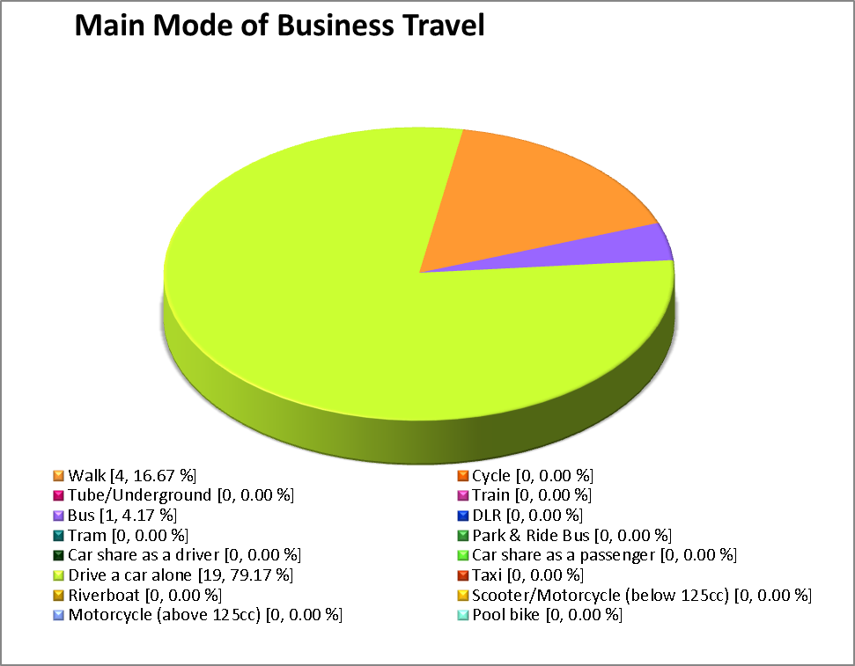

Q12: If you currently drive on your own for business journeys, what could be done to encourage you to travel by another, more sustainable mode of transport?
Preferred and supported measures for encouraging the use of more sustainable modes of business travel
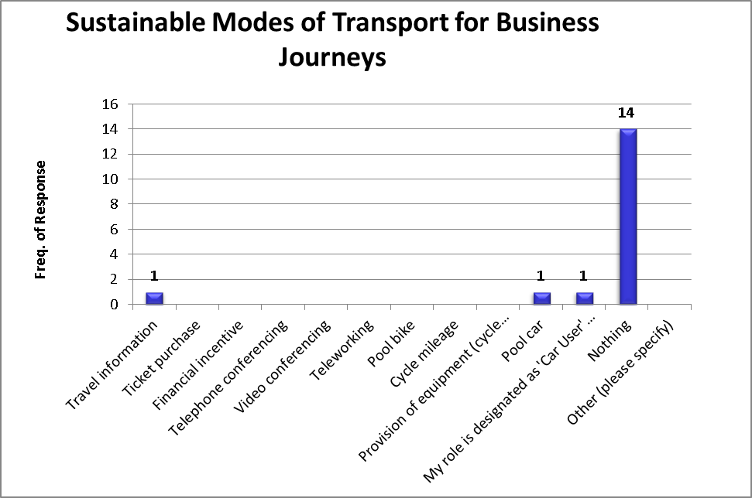

Q13: If you use your car for non-work purposes during the day, are there any facilities that could be provided on or near your work site that could be considered instead?
Response | Frequency of Response | Percentage of total | Percentage of responses
Yes | 11 | 35.5 % | 47.8 %
No | 12 | 38.7 % | 52.2 %
Not applicable - I don't use a vehicle for non work journeys during the working day
Unspecified | 8 | 25.8 %
Total | 31

Q13b: What facilities would you use if they were available on or near the site?
[Only applicable to those who answered yes to Q13]
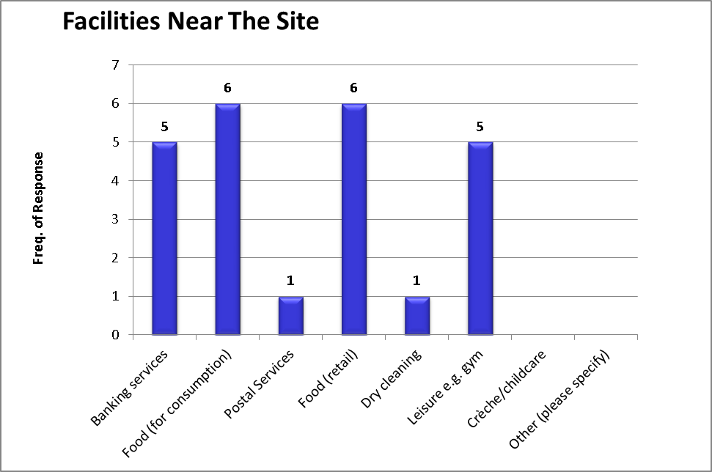

Q14: Please indicate if you already use these different working options in your role. If not used, indicate how realistic they might be to you.
 | Practice/Measure
 | TelephoneConferencing |  | Video Conferencing |  | Flexi-Working |  | Compressed working week |  | Home Working
 | Freq. | % | Freq. | % | Freq. | % | Freq. | % | Freq. | %
Currently do so | 0 | 0.0 | 0 | 0.0 | 0 | 0.0 | 0 | 0.0 | 0 | 0.0
Very realistic | 0 | 0.0 | 0 | 0.0 | 3 | 10.3 | 0 | 0.0 | 0 | 0.0
Possibly realistic | 0 | 0.0 | 0 | 0.0 | 2 | 6.9 | 2 | 6.9 | 1 | 3.4
Not realistic | 29 | 100.0 | 29 | 100.0 | 24 | 82.8 | 27 | 93.1 | 28 | 96.6
Total | 29 |  | 29 |  | 29 |  | 29 |  | 29

Q15: Given the opportunity to work from home, how likely are you to want to do this?
Response | Frequency of Response | Percentage of total | Percentage of responses
Very likely | 1 | 3.3 % | 3.3 %
Likely | 2 | 6.7 % | 6.7 %
Not likely | 2 | 6.7 % | 6.7 %
Not appropriate for my job | 25 | 83.3 % | 83.3 %
Unspecified
Total | 30

